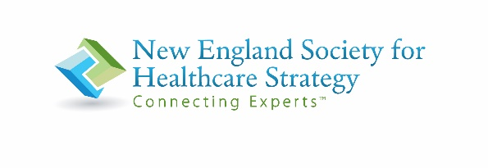
Speaker Bios – May 5, 2022

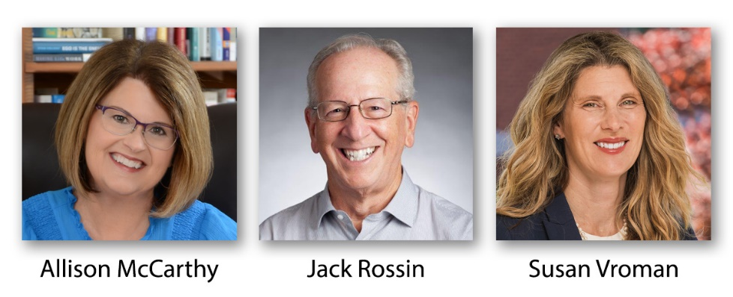

Allison McCarthy, Leadership Coach, Barlow/McCarthy
Allison McCarthy brings her 30-year career, leading physicians, practice administrators, and physician relations/recruitment directors, to her coaching practice. Using active listening and powerful questions, Allison partners with clients to support critical skills such as presence, influence, collaboration, delegation, and others to advance as leaders. She provides the support needed to encourage self-awareness – which leads to strategies for change and growth.

Named the "Strategist of the Year" by the New England Society for Health Care Strategy, Allison now hosts a podcast series focused on a range of leadership skills and challenges. She also offers webinars and articles for specific target audiences.

She is former Principal with Barlow/McCarthy – retiring from her consulting practice in December 2019. In February 2020, she became the interim President/COO of a 500+ provider medical group during one of its most challenging times – the COVID pandemic. As the health system moved out of closure, Allison shifted into the interim Director of Talent Acquisition role - helping the system move back into full operational functioning.

Through all her experience, Allison recognized the need for leadership development within health care systems. Allison completed the Leadership Coaching for Organizational Performance program at Rutgers University in August 2021 and became certified by the International Coaching Federation in 2022. She has an MBA with a concentration in Health Care from Boston University and a Bachelor of Science in Health Care Administration from Northeastern University.

Jack E Rossin, Jack E Rosssin Presentation Skills Training
Jack's business, Jack E Rossin Presentation Skills Training, teaches techniques to help speakers be more confident when giving presentations; and more thoughtful about what they say when they are in front of an audience. Jack’s training has four practice areas:

- Small group presentation skills workshops
- One-on-one coaching
- Business Development pitch coaching
- Physician Leadership Training, a workshop that covers public speaking, persuasion, and emotional intelligence.

In the past year, Jack has conducted presentation training workshops for Lawrence General Hospital, Exeter Hospital (NH), UMass Memorial Hospital, and the Peter Paul Management School for Furthering Physician Education. He has also run workshops for Vertex and Biogen.

Jack is currently an instructor at the Harvard T.H. Chan School of Public Health, a graduate school. His courses include The Art of Communications, Leading Through Speaking, and Public Speaking for Managers.

Susan R Vroman, Lecturer, Bentley University
Susan Vroman is a Lecturer of Management at Bentley University. Her research interests include the impact leadership enactment has on organizational culture and employee engagement, with specific focus on supporting flexible work arrangements.
Prior to her academic career, Dr. Vroman worked for over 20 years as an organizational effectiveness and strategic human resource management executive and advisor. With experience working as an internal and external resource, Susan’s passion and expertise lie in values-based leadership development and profit-centered culture development. She has demonstrated superior results in designing and creating engaged workforces with direct business results.

Susan has engaged with companies ranging from 8 to 50,000 employees. Her consulting niche is in entrepreneurial businesses that are “coming of age” and where the people business was recently invited to the table. Susan has served as Executive Coach (specializing in high potential emerging leaders), has designed and used tools such as 360 degree questionnaires to help leaders achieve greater professional success, and has facilitated off-site retreats to foster better results. Susan has also led Change Management initiatives ranging from organizational re-engineering to culture and human resource assimilation preparing for and in the aftermath of leadership changes, mergers, and acquisitions. Susan’s work facilitating troubled teams has also helped them to overcome obstacles to their success. Susan has been the architect of corporate universities and has also designed and developed learning and development programming for leadership development, supervisory effectiveness, and soft-skills effectiveness.

Susan holds her undergraduate degree in Communication and Human Resource Development from James Madison University, a Master’s Degree in Leadership Studies from Harvard University, and her doctorate degree in Organizational Leadership Studies from Northeastern University. She is also certified as a Senior Professional in Human Resources (SPHR), Predictive Index (PI), Myers Briggs Type Indicator (MBTI), ExperiencePoint, Emotional & Social Competency Inventory (ESCI), and in DiSC.

