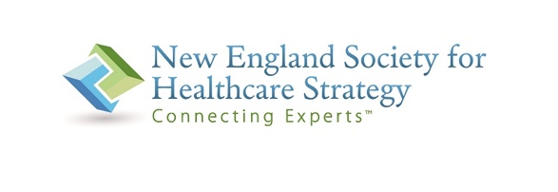

2024 NESHS Healthcare Strategist of the Year

Nomination Form

Nominator Name:

Nominator Organization: ________
Nominator email address: ________

Nominee Name:

Nominee Organization:

Why are you nominating this person?

Please include a brief biography and CV if available.

Please include professional or personal testimonials if possible.

To submit your nomination, please email this form and attachments to Deb Fiumedora, NESHS Administrator at Admin@NESHS.org by September 18, 2024.

2024 NESHS Strategist of the Year
Overview
The Healthcare Strategist of the Year is an award developed by NESHS to recognize the contributions and achievements of its members in the following three areas:
- Outstanding performance in healthcare strategy, business and network development, and physician relations
- Mentoring of colleagues early in their careers and supporting colleagues with work or professional issues
- Conducting himself or herself with the highest ethical and professional standards
Criteria:
- Nominee must be a current member of NESHS (https://www.neshs.org/member-list/) and demonstrate achievements in the three areas detailed above.
- Please use the attached Nomination Form and include a brief written narrative of how the nominee meets one or more of the characteristics above.
- Professional or personal testimonials encouraged.
Current NESHS board members are not eligible for nomination.
Past Strategist of the Year Award Recipients:
- Jean Mellett - 2023
- Karen Goyette - 2021
- Wendy Weitzner - 2020
- Susan Fahmy - 2019
- Todd Herrmann – 2018
- John Weaver – 2017
- Gail Costa – 2016
- Beth Greenspan – 2015
- Mary Sweeney – 2014
- Jeff Hughes– 2013
- Christine Gallery – 2012
- Allison McCarthy – 2011
- Don Seymour – 2010
- Donna Ross – 2009
- Amy MacNulty – 2008
- Deb Joelson – 2007

